# *Database Management I (420-D10-HR)*

# *Lab 07 - The Logical Data Model*

Date assigned: Monday, September 19, 2016

Date due: Monday, September 19, 2016, 4:50pm

**Name**: \_\_\_\_\_\_\_\_\_\_\_\_\_\_\_\_\_\_\_\_\_\_\_\_\_\_\_\_\_\_\_\_\_\_\_\_\_\_\_\_\_\_*\_*

|  |  |  |
| --- | --- | --- |
| Question | **Mark** | **Out of** |
| Table 1Relationships |  | **5** |
| Data Models for Table 1 |  | **21** |
| Mountain View Data Model  - relationships |  | **3** |
| Airline Data Model  - relationships |  | **9** |
| Table 2 – Real Estate Attributes |  | **10** |
| Mountain View Data Model with attributes |  | **3** |
| Organization |  | **5** |
| Total |  | **56** |

**Learning Objectives**

Upon successful completion of this lab exercise, the student will be able to:

1. convert many-to-many relationships (non-specific relationships) to associative entities
2. categorize attributes according to atomicity, explicitness, multiplicity, optionality and uniqueness
3. clearly define attributes
4. determine the entity or relationship to which an attribute belongs
5. decompose composite attributes into atomic attributes
6. represent different types of relationships and attributes on an entity relationship diagram using Oracle Data Modeler

**To Be Handed In:**

1. The ***username*\_D10\_L07\_Logical\_Data\_Model** folder containing the ***username*\_D10\_L07\_Logical\_Data\_Model.docx** Word document and the Data Modeler diagrams should be zipped and uploaded to **Moodle**.

**To Start:**

1. Create a new folder called ***username*\_D10\_L07\_Logical\_Data\_Model** for your lab drawings.
2. Use slides D10\_S08 and notes:D10\_N03, D10\_N04 as your reference. You can find these on the course Moodle page. You may also use any other reference that explains these concepts.

# Types of Relationships

***Purpose:*** Learn how to identify and draw recursive, binary and ternary relationships.

***To Do:***

## Identify the relationships in **Table 1** as recursive, binary or ternary.

**Table 1**

| **Relationship Description** | **Degree of**  **relationship** |
| --- | --- |
| 1. A borrower borrows one or more books from one or more branches of a library. The same book may be available at more than one branch. A borrower may borrow from any branch. | Ternary |
| 1. A part may be manufactured from one or more other parts. A part may be a component of one or more other parts. | Recursive |
| 1. A sales assistant sells a product to a customer. A customer may purchase many products sold by different sales assistants. A product may be sold to many customers by many sales assistants. | Ternary |
| 1. A horse has a sire and a dam. A horse may be a sire or a dam for many horses. (Note: a sire is the “father” horse and a dam is the “mother” horse.) | Recursive |
| 1. A baseball team consists of nine players. A player can only play on one team. | binary |

## Create the data models using Oracle Data Modeler containing the relationships described in **Table 1**. Save the model as ***username*\_D10\_L07\_Relationship\_Types**. Copy the data model to the appropriate location in ***username*\_D10\_L07\_Logical\_Data\_Model.docx**.

## *Insert Logical Data Model here. There are to be no many:many relationships.*

# Associative Entities

***Purpose:*** Learn how to convert many-to-many and ternary relationships to associative entities.

***To Do:***

## D10_L04_Care_Centre.pngA portion of the Mountain View Community Hospital conceptual data model is shown here. Convert it to a logical data model by eliminating the many-to-many relationship. Copy the data model to below

*Insert your diagram here:*

*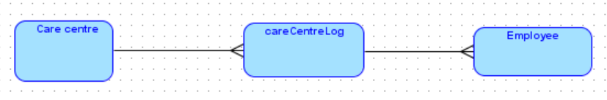*

## Consider the airline reservation system data model and the business rules below. Sample forms are at the end of this lab document. Create a new data model replacing all many-to-many relationships with an appropriate associative entity. Copy the data model to the appropriate location to below:

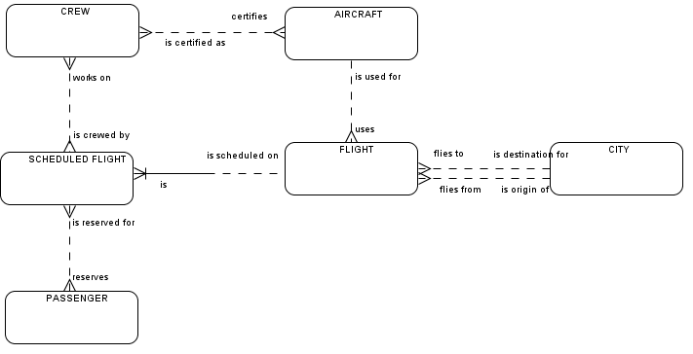

The following business rules were discovered during a JRP session with the users:

* 1. A flight flies between two cities leaving and arriving at the same time each day.
  2. A passenger makes a reservation for a specified flight on a specified day.
  3. Each scheduled flight has a crew of at least three people: the pilot, co-pilot and at least one flight attendant. There may also be a first officer and more flight attendants.
  4. The departure and arrival cities are identified by airline codes. (e.g. YOW is Ottawa).
  5. Only pilots can be certified on aircraft.

*Insert your Airline Reservation System Data Model here:*

# Attributes

***Purpose:*** Learn to categorize attributes according to atomicity, explicitness, multiplicity, optionality and uniqueness, to clearly define attributes and to determine the entity or relationship to which an attribute belongs.

***To Do:***

## The following entity relationship diagram was drawn to represent a real estate firm that lists properties for sale. Complete **Table 2** with the attribute details.

**Table 2:**

| **Attribute** | **Entity** | **Atomic or Composite?** | **Explicit or Derived?** | **Singular or Multi-valued** | **Mandatory or Optional?** | **Unique Identifier?** |
| --- | --- | --- | --- | --- | --- | --- |
| Office number | SALES  OFFICE | Atomic | Explicit | Singular | Mandatory | yes |
| Office Address | SALES  OFFICE | Composite | Explicit | Multi-valued | Mandatory | no |
| Office Phone number | SALES  OFFICE | Atomic | Explicit | Singular | Optional | no |
| Number of properties | SALES  OFFICE | Atomic | Derived | Singular | Optional | no |
| Employee ID | EMPLOYEE | Atomic | Derived | Singular | Mandatory | yes |
| Employee Name | EMPLOYEE | Composite | Explicit | Multi-valued | Mandatory | no |
| Employee Phone Number | EMPLOYEE | Atomic | Explicit | Singular | Optional | no |
| Property ID | PROPERTY | Atomic | Derived | Singular | Mandatory | yes |
| Property address | PROPERTY | Composite | Explicit | Multi-valued | Mandatory | no |
| Date listed | PROPERTY | Composite | Explicit | Multi-Valued | Optional | no |
| Listed Price | PROPERTY | Atomic | Explicit | Singular | Optional | no |
| Owner ID | OWNER | Atomic | Derived | Singular | Mandatory | yes |
| Owner Name | OWNER | Composite | Explicit | Multi-valued | Mandatory | no |
| Owner Phone number | OWNER | Atomic | Explicit | Singular | Optional | no |
| Owner Email address | OWNER | Atomic | Explicit | Singular | Optional | no |
| Total property value | OWNER | Atomic | Derived | Singular | Optional | no |
| Percentage  Owned | OWNER  Owns  PROPERTY | Atomic | Derived | Singular | Optional | no |

## Add the following list of attributes in the Mountain View data model you created earlier. Copy the completed diagram to below:

| **Attribute** | **Entity/Relationship** | **Mandatory or Optional** | **Unique Identifier?** |
| --- | --- | --- | --- |
| care\_centre\_id | care centre | m | y |
| care\_centre\_name | care centre | m | n |
| employee\_id | employee | m | y |
| employee\_name | employee | m | n |
| hours\_per\_week | employs/works at | m | n |

*Insert Mountain View Data Model here* **Sample Airline Forms**

**Flight schedule**

|  |  |  |  |  |  |
| --- | --- | --- | --- | --- | --- |
| **Flight #** | **Aircraft** | **From** | **To** | **Depart** | **Arrive** |
| HR129 | CRA | YOW | YQM | 9:05 | 11:50 |
| HR128 | 777 | YOW | YFC | 9:05 | 10:55 |
| HR101 | DH1 | YOW | YHZ | 12:15 | 12:48 |
| HR533 | 321 | YUL | YFC | 13:45 | 17:05 |
| HR534 | DH1 | YHZ | YUL | 16:45 | 18:10 |
| HR535 | 777 | YSJ | YOW | 18:45 | 20:05 |
| HR536 | DH1 | YFC | YUL | 12:20 | 12:25 |
| HR537 | DH1 | YUL | YOW | 13:25 | 14:02 |

**Flight Confirmation Form**

### **Passenger Reservation Confirmation**

Reservation Number: ABC123

Passenger Name: Sam Ovar

Phone Number: 819 555-5555

Date of Issue: Sept 18, 2013

|  |  |  |  |  |  |  |  |
| --- | --- | --- | --- | --- | --- | --- | --- |
| **ITINERARY** | | | | | | | |
| **Flight**  **Number** | **Aircraft** | **Depart** | | | **Arrive** | | |
| **City** | **Date** | **Time** | **City** | **Date** | **Time** |
| HR128 | 777 | Ottawa (YOW) | 19-10-07 | 9:05 | Fredericton (YFC) | 19-10-10 | 10:55 |
| HR536 | DH1 | Fredericton (YFC) | 29-10-07 | 12:20 | Montreal (YUL) | 29-10-10 | 12:25 |
| HR537 | DH1 | Montreal (YUL) | 29-10-07 | 13:25 | Ottawa (YOW) | 29-10-10 | 14:02 |

**Crew Roster for Flight HR128 on 19-10-2013**

|  |  |  |  |  |
| --- | --- | --- | --- | --- |
| **Crew id** | **Name** | **Position** | **Flight** | **Flight Role** |
| 1234 | Snoopy Dog | Pilot | HR128 | Pilot |
| 1233 | Red Baron | Pilot | HR128 | Co-pilot |
| 1232 | Charles Brown | Flight Attendant | HR128 | Flight Attendant |
| 1222 | Lucy Smith | Flight Attendant | HR128 | Flight Attendant |
| 1241 | Peppermint Patty | Flight Attendant | HR128 | Flight Attendant |

**Pilot Certifications**

| **Crew-id** | **Aircraft Code** | **Aircraft Manufacturer and Model** | **Last Date of Certification** |
| --- | --- | --- | --- |
| 1234 | 777 | Boeing 777-300ER | 20-03-10 |
| 1233 | 777 | Boeing 777-300ER | 18-10-09 |
| 1234 | DH1 | de Havilland Dash 8-100 | 15-11-09 |
| 1233 | DH1 | de Havilland Dash 8-100 | 28-06-10 |
| 1233 | CRA | Canadair CRJ-705 | 26-04-09 |
| 1234 | 321 | Airbus A321-200 | 02-06-10 |